Still View Controller (SVC)

Vibration blurs images of microscopes, telescopes and similar high magnification optical devices and restricts processes such as shooting automation and semiconductor etching. Using economical passive mechanical vibration isolators and dampers, the vibration amplitude, and thereby--up to a limit magnification level--the blurriness may be reduced. Beyond that, expensive active isolation and damping technique may still work.

Alternatively, expensive high-speed camera may work as well. That however, has other limitations associated with the small amount of light a short exposure time allows to illuminate the object. One may play back and slow down the video, but cannot observe in real time that way. Up to half of the automated overnight microscope shots need to be discarded for being blurry from self-generated and ambient vibrations. Extreme illumination may destroy the samples, thus often prohibited in biological microscopy. Semiconductor buildings are built extremely rigid and expensive, just to ensure vibration-free etched wafer production.

The SVC solves this problem by shooting pictures only as long as the object is very near to its average position and morphs or hold pictures or shuts off illumination in between. Its adaptive algorithm predicts from its own 3-D acceleration, velocity or inclination measurements the next average position. In microscopy, it makes vibration isolation and high-speed imaging obsolete.

The SV distinguishes between searching and targeting mode and overrides trigger command to sharpen shooting of pictures, laser impulses and even bullets. Thus, it is useful not only in microscopy and in telescopy, but in clinical monitoring, diagnostics and surgery involving hand held devices. Pointers, cameras and camcorders are other examples of use.

Prototypes

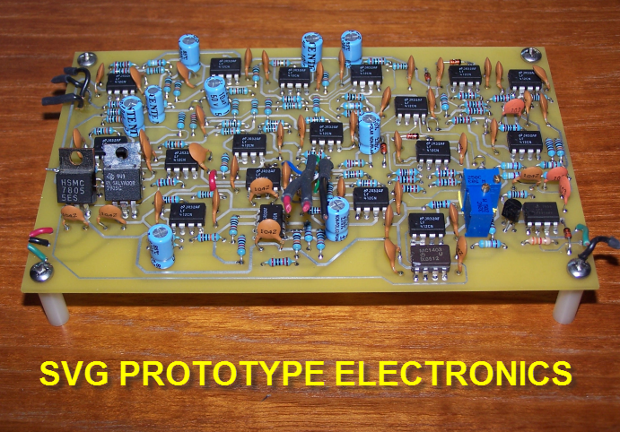
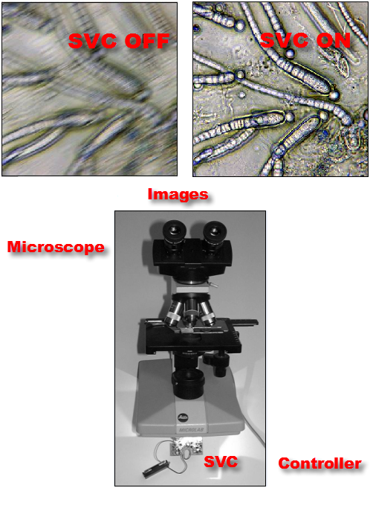

The generic SVC electronic controller shown above first overrides camcorder signals based on its accelerometer data stream fed from a 3-D accelerometer. This unit is powered from a wall outlet. The SVC shown second replaces the microscope illumination with a bright LED array flickering strobe. The accelerometer chip is built on its small PCB board. It is powered by a AA size battery. Both use an event triggered PID controller PCB circuit.

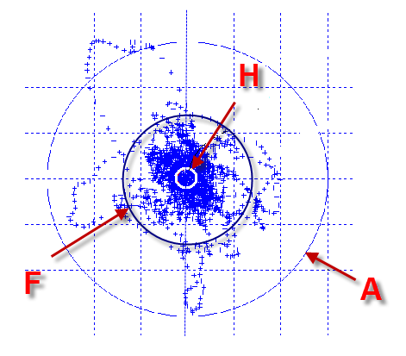

The plot above illustrates hits (marked by + signs) of a pulsating hand held laser gun. The SVC is activated for hits inside circle A. The SVC neglects hits outside circle A, considering that the aiming is still in the tracking and not yet in the aiming mode. Within circle A, it averages the hits based on their latest positions and predicts the next positions. Firing occurs within circle F. If the trigger is released within Circle H, the controller considers it a hit and it does not override the actual triggering. However, if the firing happens between circles A and F, the controller overrides actual triggering based on its prediction. Then, it releases the trigger only, when the prediction or measurement falls within circle H. In training mode however, it may just dim the light in proportion to how far the aim misses the target.

The accuracy of firing improvement is proportional to the ratio of the areas of circle F to circle H. That is to R_{F}²/R_{H}², where R denotes the corresponding radii. For the recording shown above, that ratio is 50x. The radii of circles A, H and F are programmable by digital or analog dialing. The grid illustrates the target size. That could be as small as a backpack with a roadside bomb from 2 kilometers afar. One may however think of happier applications, for instance, eye surgery with a handheld or a hand triggered laser gun. In education and conferences, a still-triggering laser pointer removes the signs of nervous jittering of a presenter, calming her and the audience down and allows concentrating on the presentation, rather than on the presenter (see below).

Such applications suffice with 2-D motion sensors. Inclination-rate sensors are inexpensive, small and well suited for similar applications. The above recording and trigger control used 2-D accelerometer chips. In any case, the electronics are small, simple and inexpensive. Readymade software may be modified for this control task.

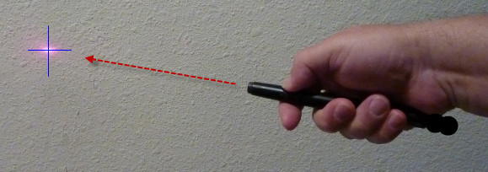

A similar application to the still laser pointer is the still photo and video shot. Currently some cameras and camcorders are equipped with a motion control system, which moves around the microchip with the photo sensors or tilts the optical lens. Obviously, that may be slow to follow some hand-jitter and more expensive than a SVC program or microchip having no moving components.

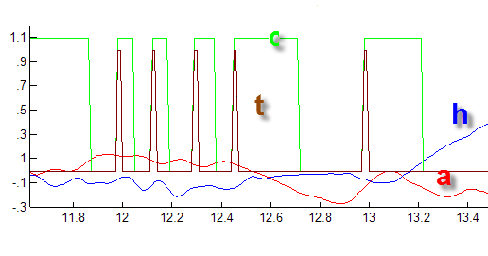
The above plot represents some processed signals of a camera vibration, where plots h and a illustrate the heading and azimuth signals, and c and t the control and trigger time history signals respectively. The exposure (shooting) or morphing may extend to the duration of the still signal c, which is ON, when the vectorial sum of h and a is less than an adjustable preset value: R_{H}² > (h²+a²)^{1/2}. Otherwise, signal c is OFF.

For more information, please contact the inventor, Dr. Zoltan Kemeny:  US Pat. Pend.
Tel: 888-588-0999, Fax: 480-456-0999, Email: ZoltanKemeny@Cox.Net Copyright©, Kemeny, 2011.

